Maria Verdú, Samuel Blanco i Alba Fernandez
Pilates
Material: we only use mats.

We will be on the “stage” all the class for give the instructions.
First of all we will start with some stretching exercises.
- Stretch the leg and with the hand we touch our food. (1 minute for leg)
- Stretch the two legs in front of you and your hands touch your feet. (1 minute)
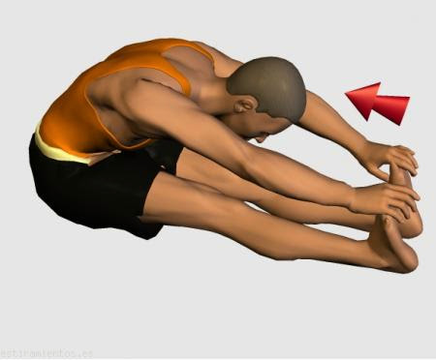
- Open your legs and go to the front as much you can. (1 minute)
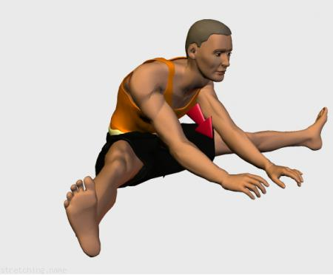
- Stand up and put your foot with your ass, your leg must be bent (1 minute for leg)
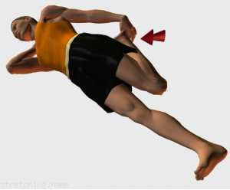
- Stand up and try touch your feet without bent your knees. (1 minute)
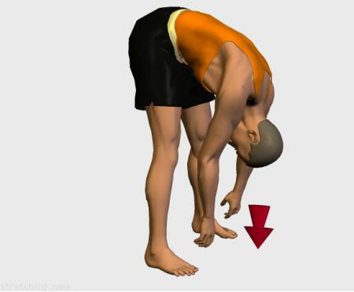
- Put your hands together and your arms in front of you (1 minute)
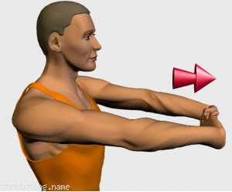
- Put one arm in your back and with the other arm press press down (1 minute for arm)
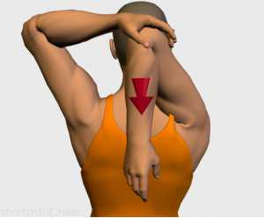

Now all of us gonna do some postures simples

- Stretch in the floor and try touch your head with your feet (1 minute)
- This posture is similar to the bridge but with one leg up. (1 minute for leg)
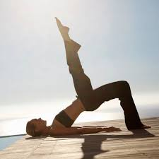
.3. get up, stretch your arms and go down flexing your knees ( 1 minute)

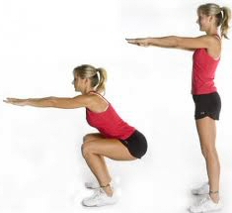

- Stretch in the floor and lift your legs 90 degrees, and go up and down with abs ( 1 minutes)
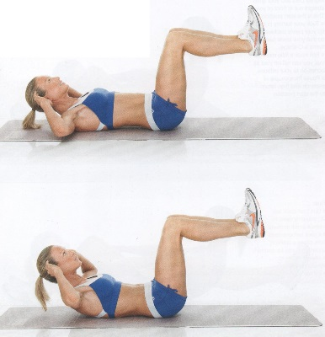

- Stretch in the floor and put up your body, your legs has to be in front your face (1 minutes)
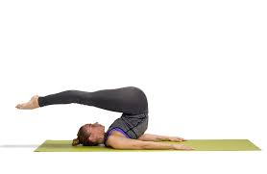
- Put on four legs and stand up one leg and the contrary arm. (1 minute for leg and arm)
- Do the “SUPERMAN” put your stomach in the floor and up your arms and legs (1 minutes)

- With one arm support the pes of your body (1 minute for arm)
- Catch one leg and press to your chest, it’s not necessary touch your chest. (1 minute for leg)
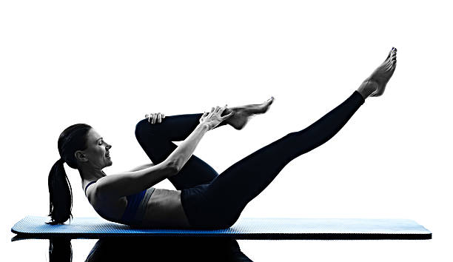
- Do a mountain with your body, don’t bent your knees. Put your ass up and touch the floor with your feet and hands. (1 minutes)

- Put your legs and trunk up and touch the floor with your ass, try not follow down and it’s like a little abdominal (1 minutes)
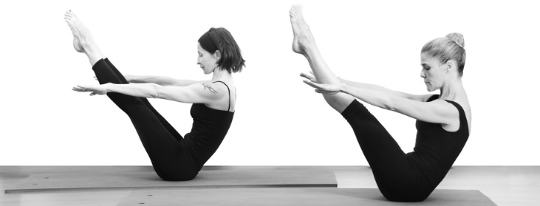

- Put your head down touching the floor and knees touching your chest, the arms has to be strech on the floor in front. (1 minutes)

